* + 1. **Forfeiture/Refund of Accounts not yet Booked**

Accounts that are not yet booked or account that payments do not yet exceed the 25% Net TCP threshold, only has a Sales Quotation, Sales Order, AR Invoices for Miscellaneous Payments and A/R Down Payment Invoices for TCP Payments. This also includes accounts with reservation payment only. Please see sample Relationship Map below:

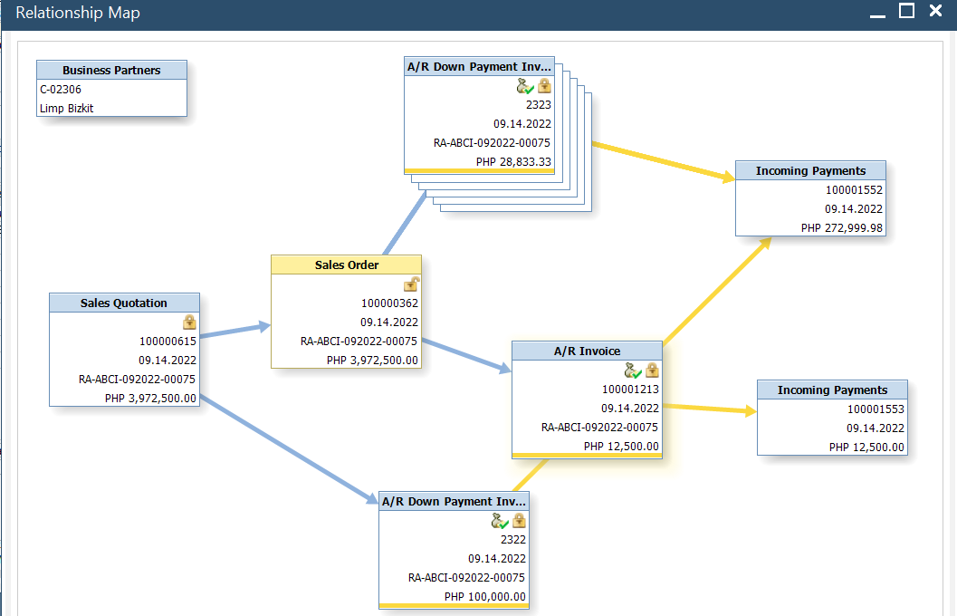

To forfeit/refund an account that is not yet booked, create an A/R Invoice:

1. Find and open the **Sales Order** of the quotation to be forfeited/refunded. Go to Sales A/R > Sales Order and click ctrl + F. You may search by filling in the customer name, project, block and lot fields or fill an asterisk (*) on any field and click enter.

For accounts with reservation payment only, open the **Sales Quotation** module instead of Sales Order.

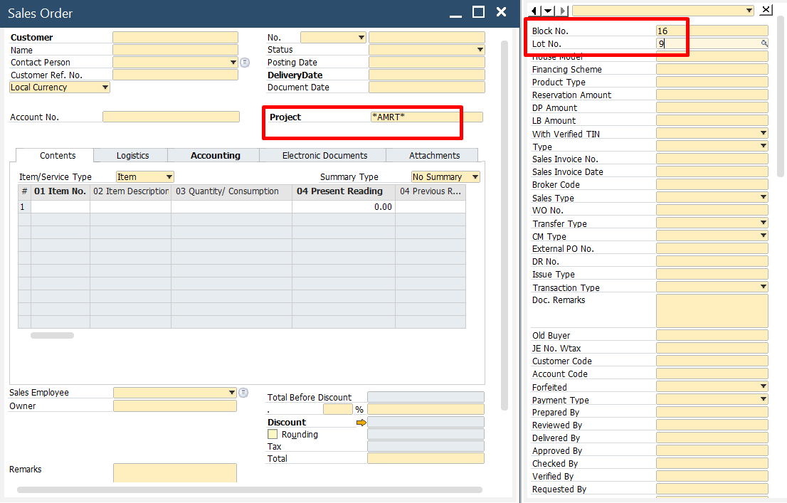

1. Once the sales order is opened, go to the lower right corner of the document and click **‘Copy To’** and select **‘A/R Invoice’.**

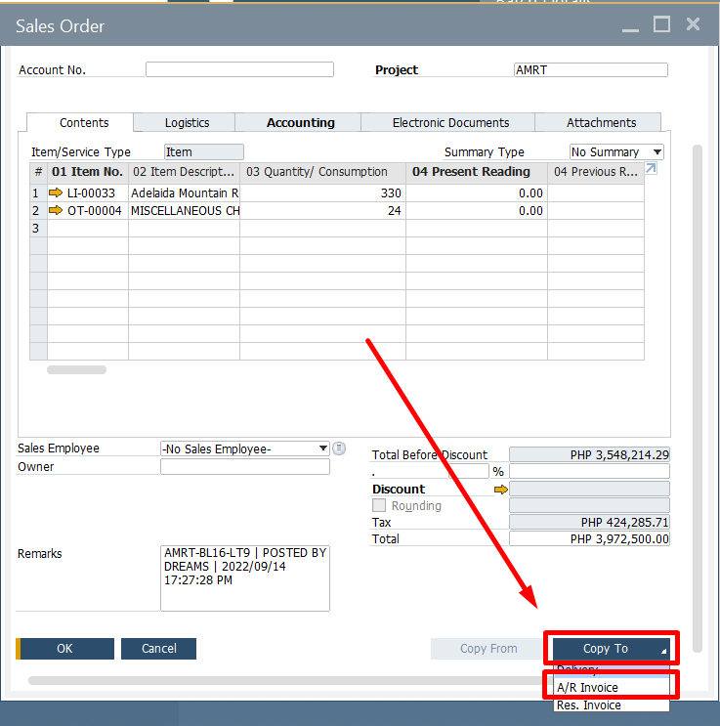

The A/R invoice will serve as the forfeiture/refund document.

1. All details from the Sales Order will be copied to the A/R Invoice. Since no Sales and Cost is recognized yet, delete **all item**s in the Contents tab by right-clicking the row/item number and clicking **‘Delete Row’.**

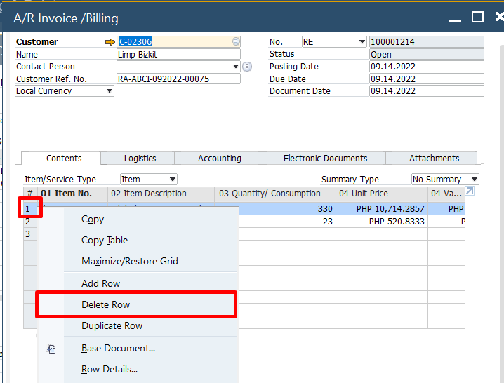

1. In the ‘Total Down Payment’ field, make sure the amount reflected is the total payments made by the buyer so far.

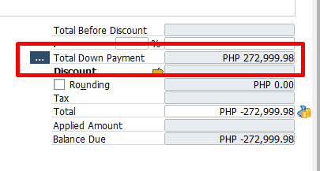

If not, click the ellipsis button and make sure all the down payments related to the project, block and lot are checked. You may refer to the Remarks column for the location information.

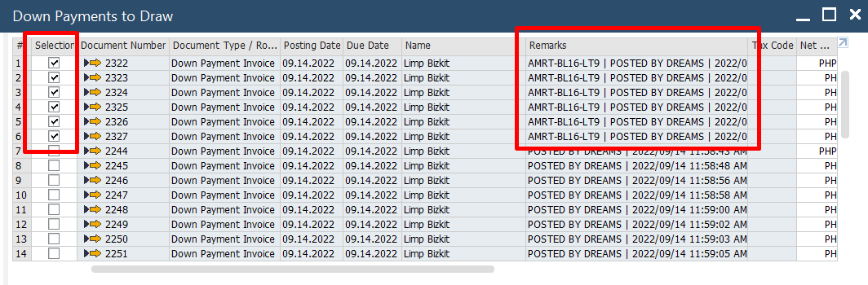

Then, click ‘OK.’

1. Under the Contents tab, enter the following:

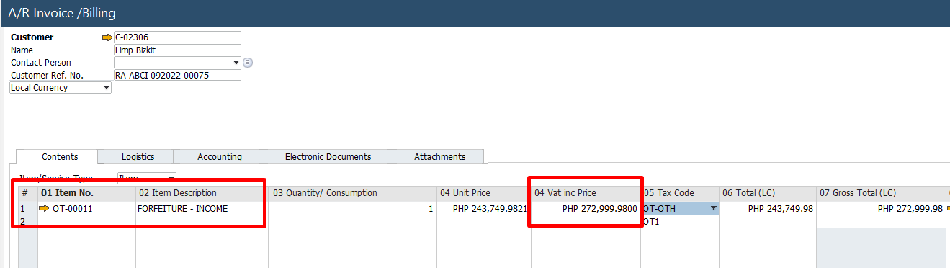

1. **Forfeiture/Refund – Income** – enter amount of forfeiture income expected to be recognized. Quantity is always 1.
2. **Commission and Incentives** - enter amount to be reversed. Quantity is always 1.
3. **Admin and Other Fees** – if there are any. Quantity is always negative 1.
4. On the User-defined fields window (Ctrl + Shift + U), select **‘Forfeiture’ or ‘Refund’** on the **‘Transaction Type’** field.

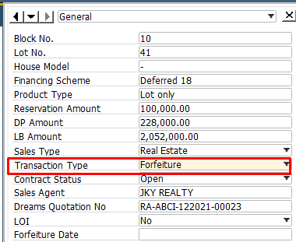

1. The footer of the document of a Forfeiture transaction will have a zero Balance Due while a Refund transaction will have an amount on the balance due which is the amount to be paid to the customer.

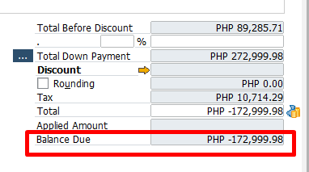

1. If there is an amount for refund, you may change the account to recognize payable under the **Accounting** tab in the **Control Account** field.

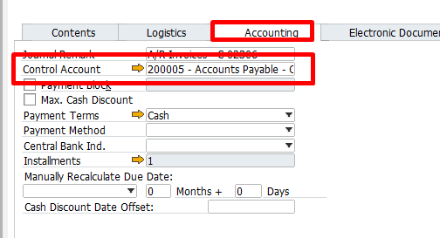

1. Review Journal Entries before adding the document by right clicking on the context menu then ‘Journal Entries Preview’.

Sample Journal Entry:

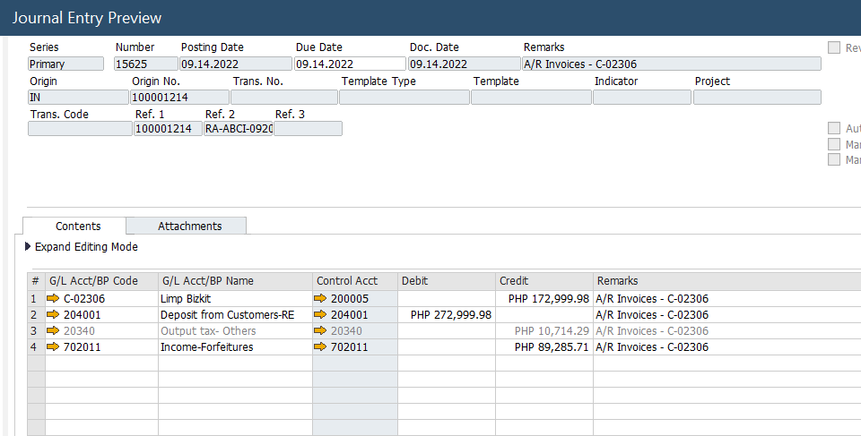

1. Add the document when all details are reviewed. Adding the forfeiture document will trigger the following:
2. All marketing documents (Sales Quotation to Invoices) will have a Forfeited/Refunded Contract Status.
3. The property under the Batch Details will now reflect an ‘Available’ Status.
4. The contract/quotation will be shown in the Forfeitures module in DREAMS.

For refunded accounts, this will be paid by Accounting Department thru the **Outstanding Payments** module. The Refund document status will be changed from ‘Open’ to ‘Close’ once refund has been fully paid.

* + 1. **Forfeiture/Refund of LOI Accounts**

The default journal entry to record a payment before booking is to recognize Deposit from Customers. For LOI accounts, every payment creates a separate journal entry to derecognize Deposit from Customer and recognize Accounts Payable – Others.

All steps to forfeit not yet booked as discussed above should be followed. Since the default entry on forfeiture/refund recognized a Deposit from Customer, an additional step should be made to derecognize this and recognize a debit to AP – Others to reverse the payable recognized during payments. This will be done on the **Journal Entry module.**

On the example above, if the account was an LOI account, the screenshot below should be the journal entry to be made:

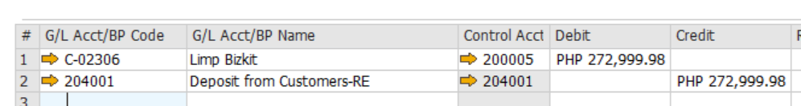

Make sure to provide other details such as Account No., Project, Block and Lot on the UDF window.

**1.1.3 Forfeiture/Refund of Accounts Booked**

Accounts that are already booked or account that payments exceeded the 25% Net TCP threshold, has a Sales Quotation, Sales Order, AR Invoices for Miscellaneous Payments, A/R Down Payment Invoices for TCP Payments and an A/R Reserve Invoice (Sales Invoice). Please see sample Relationship Map below:

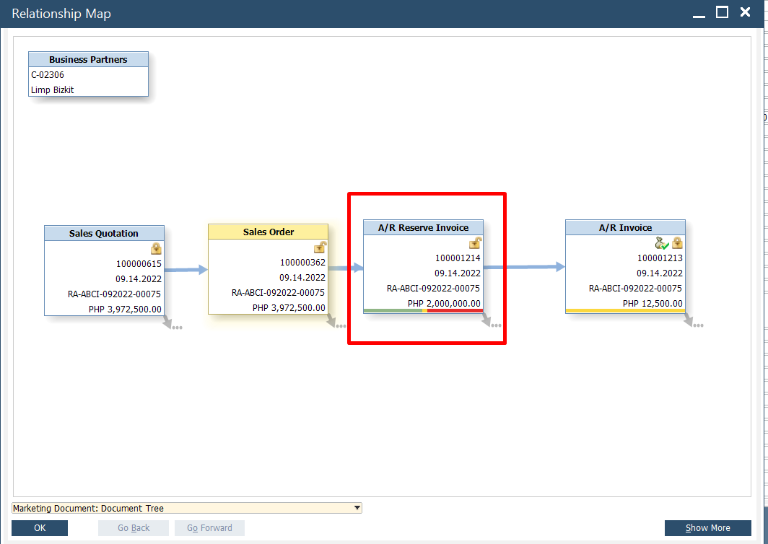

To forfeit/refund an account that is not yet booked, create an A/R Invoice:

1. Find and open the A/R Reserve Invoice of the quotation to be forfeited/refunded. Go to Sales A/R > A/R Reserve Invoice and click ctrl + F. You may search by filling in the customer name, project, block and lot fields or fill an asterisk (*) on any field and click enter.



1. Once the A/R Reserve Invoice is opened, go to the lower right corner of the document and click ‘Copy To’ and select ‘A/R Credit Memo’. The A/R Credit Memo will serve as the forfeiture/refund document.

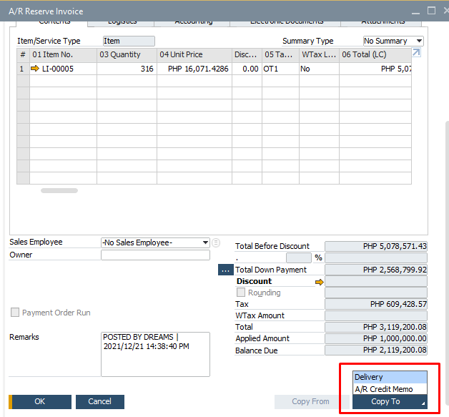

1. After copying the details to an ARCM document, open the applied down payments on the footer side of the document by clicking the ellipsis button besides **‘Total Down Payment.’**

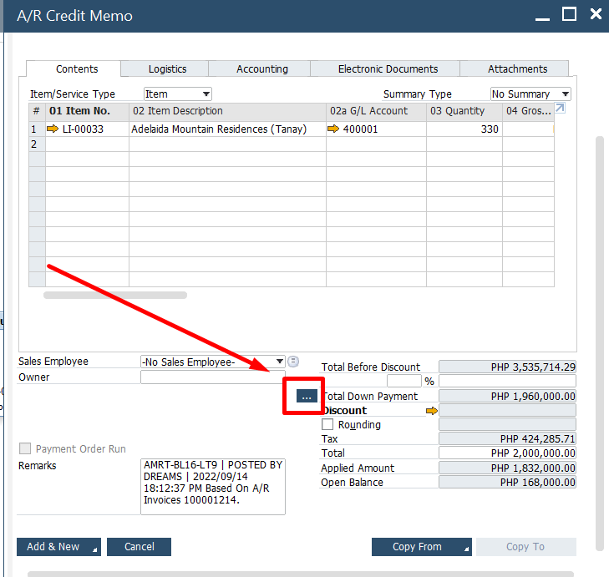

Since these down payments (Deposit from Customers – RE) were already reversed, **untick all** to no longer recognize a Deposit from Customers – RE this transaction.

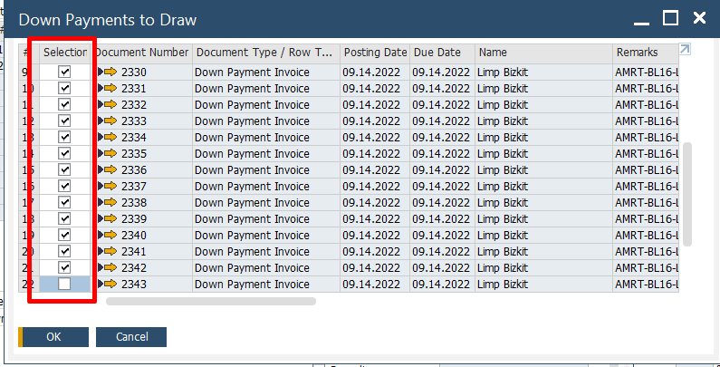

1. All the details from the A/R Reserve Invoice will be copied to the A/R Credit Memo. To add the forfeiture/Refund item, enter the following under the Contents tab:

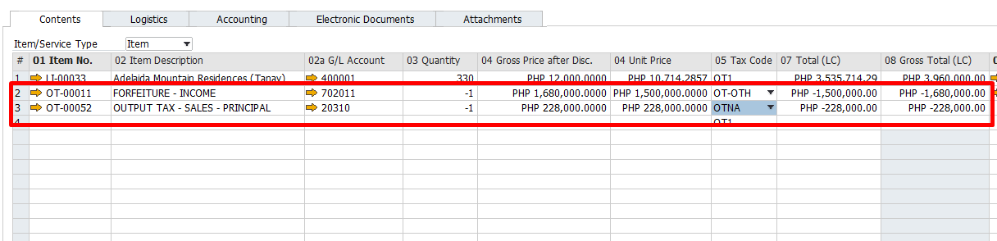

1. Forfeiture/Refund – Income – enter amount of forfeiture income expected to be recognized. This should be a negative amount.
2. Output Tax – Sales – Principal – input the equivalent output tax of the total TCP Paid. If the account is a deferred sale, amount should also be based on the total TCP Paid and not on the whole TCP amount. This should be a negative amount.
3. Incentive and Commission – enter amount of Cost of Sales – RE and Prepaid Commission expected to be reversed. This should be a negative amount.
4. Admin and Other Fees – if there are any. This should be a negative amount.
5. On the User-defined fields window (Ctrl + Shift + U), select ‘Forfeiture’ or ‘Refund’ on the ‘Transaction Type’ field.



1. The footer of the document of a Forfeiture transaction will have a zero **Open Balance amount**. Should there be a **refund**, this will have an amount on the balance due which is the amount to be paid to the customer.

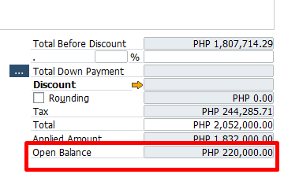

1. Review Journal Entries before adding the document by right clicking on the context menu then ‘Journal Entries Preview’.

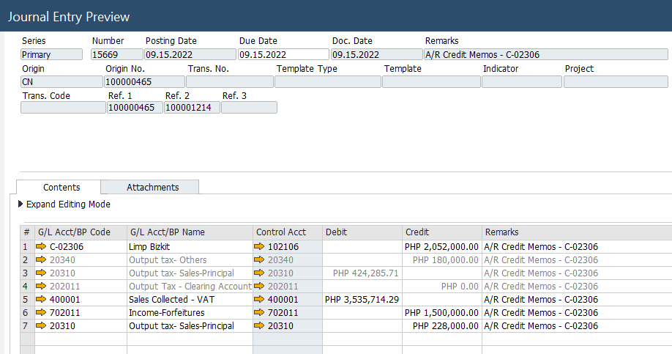

1. Add the document when all details are reviewed. Adding the forfeiture document will trigger the following:
2. All marketing documents (Sales Quotation to Invoices) will have a **Forfeited/Refunded Contract Status.**
3. The property under the Batch Details will now reflect an **‘Available’** Status.
4. The contract/quotation will be shown in the **Forfeitures module** in DREAMS.

**Notes on the Journal Entry**

1. The contract receivable amount is the sum of the contract receivable (gross of VAT) to be reversed and the amount to be refunded. Reverse this amount on a separate journal entry to recognize the correct payable account if necessary.
2. This Journal Entry is not yet the final entry to reverse the buyer’s account on the books. The remaining accounts to be reverse such as Sales – Uncollected and Cost of Sales account should be posted on a separate journal entry. Please see steps below:
3. Go to Financials > Journal Entry.

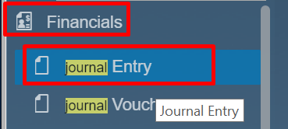

**Contents tab**

1. For G/L Accounts with sub ledgers or ‘Control Accounts’ such as receivables and payables, press Ctrl + tab to open the list of Business Partners. Then search for the buyer’s name.

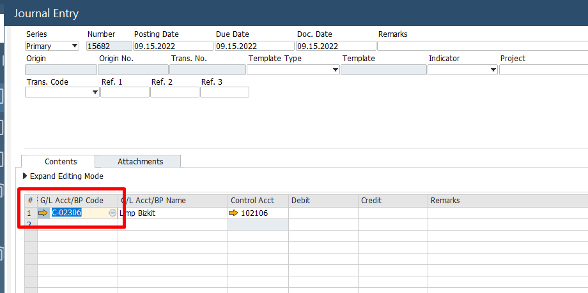

Make sure to select the correct account on the ‘Control Account’ field. To select another, delete the data on the cell first then press tab or the hamburger button.

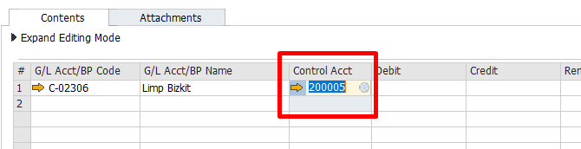

1. For expense and income accounts, you may directly press tab or click the hamburger button

Sample Journal Entry:

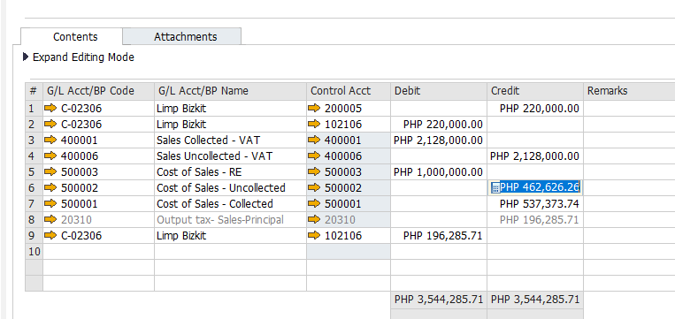

1. This is to record the payable to customer.

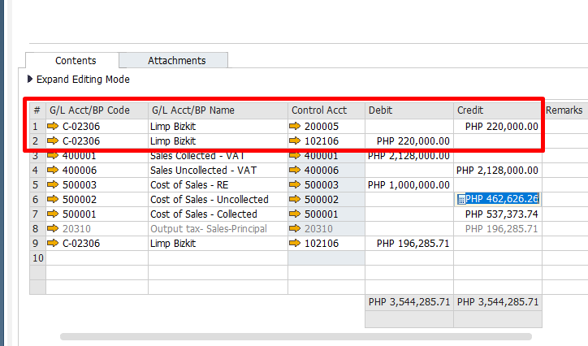

1. This is to derecognize Sales and Cost of Sales.

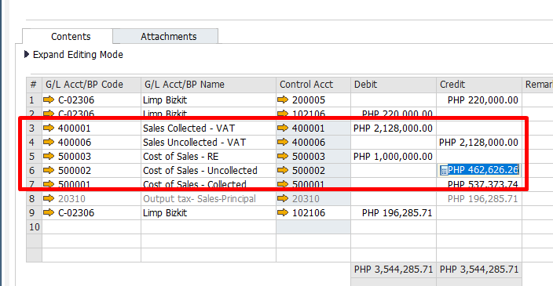

1. To derecognize excess Output Tax and the VAT portion of Contract Receivable recognized on ARCM due to system limitations.

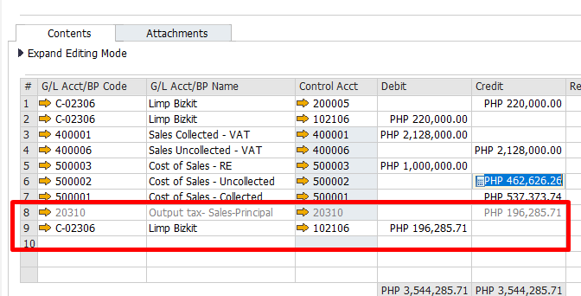

Note that these sample entries are not exhaustive, you may refer to the **ABCI - Journal Entry Report** on the accounts and the corresponding amounts to reverse.

Lastly, enter the following details on the User-defined windows on the Journal Entry module.

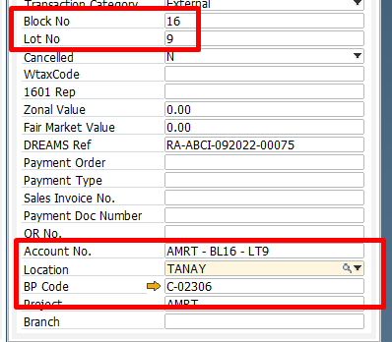

Then, add the journal entry.

For refunded accounts, this will be paid by Accounting Department thru the Outstanding Payments module. The Refund document status will be changed from ‘Open’ to ‘Close’ **once refund has been fully paid.**